Backwoods Regional Library System

The Backwoods Regional Library System (BRLS) is a system that is intended to

# Bug Report:

1. Incorrect calculation of fines: When a book becomes overdue by one day, no fine is imposed

2. Incorrect fine amount levied: When a fine is incurred, the amount of fine is half than the amount that is intended

## Bug 1 – Incorrect Calculation of fines:

Replication:

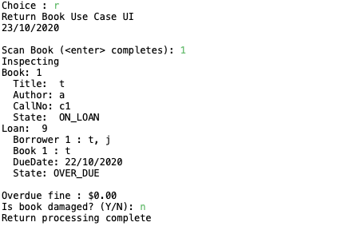

Simplification:

H0 – problem in library.calculateOverDueFine

T0 – check if days overdue amount correct in method

After play – Patron is not issued a fine even though the loan is one day overdue

R0 – loan sane before run (one day overdue), amount of days overdue is returned as 0

Hypothesis busted – bug must be in days overdue calculation (Calendar.getDaysDifference)

H1 – Calendar.getDaysDifference not returning correct day

T1 – check if amount of days difference between current date and loan date is correct

R1: loan sane before run (one day overdue), difference in milliseconds is correct yet difference in days in incorrect.



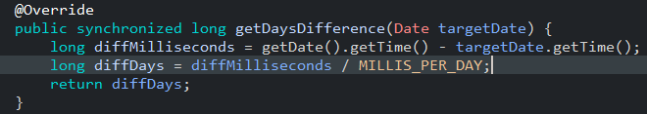

Hypothesis confirmed – bug is in Calendar.getDaysDifference

Simplification test:

test/library/entities/IncorrectCalculationOfFinesTest.java

H2 – diffDays calculation is incorrect due to a rounding issue

T2 – ensure that all values are correct going into the diffDays calculation

R2 – the milliseconds difference is correct yet the days difference is incorrect as the value is rounded down

Hypothesis confirmed – The calculation of diffDays is incorrect due to a rounding error in the calculation.

H3 – Bug is in line 66 – should make diffDays round up

Before:

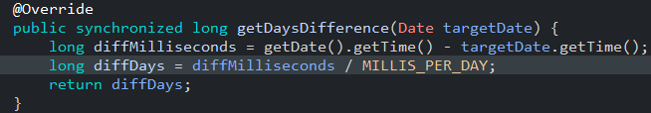

After:

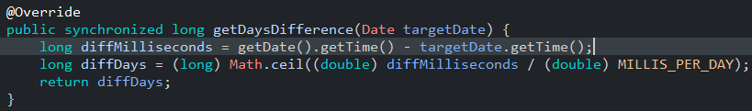

Hypothesis confirmed – The bug was caused by a rounding issue and correcting this issue solves the problem.

## Bug 2 – Incorrect **Fine Amount Levied**:

1. When a fine is incurred, the amount of the fine reported is half the amount intended
2. Replication:
3. 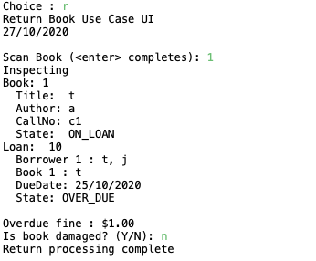
4. Simplification:
5. H0 – problem in library.calculateOverDueFine
6. T0 – check if days overdue amount correct in method
7. After play – Patron is not issued a fine even though the loan is one day overdue
8. R0 – loan sane before run (one day overdue), amount of days overdue is returned as half of the expected amount
9. Hypothesis busted – bug must be in days overdue calculation (Calendar.getDaysDifference)
10. H1 – Calendar.getDaysDifference not returning correct day
11. T1 – check if amount of days difference between current date and loan date is correct
12. R1: loan sane before run (one day overdue), difference in milliseconds is correct yet difference in days in incorrect.
13. 



1. Hypothesis confirmed – bug is in Calendar.getDaysDifference
2. H2 – diffDays calculation is incorrect due to incorrect values
3. T2 – ensure that all values are correct going into the diffDays calculation
4. R2 – the milliseconds difference is correct yet the MILLIS_PER_DAY variable is double what it should be: it should be 86400000 instead of 172800000
5. Hypothesis confirmed – The calculation of diffDays is incorrect due to the incorrect MILLIS_PER_DAY variable.
6. Simplification test:
7. test/library/entities/IncorrectFineAmountLeviedTest.java
8. H3 – Bug is in line 10 – should make MILLIS_PER_DAY 86400000l
9. Before:
10. 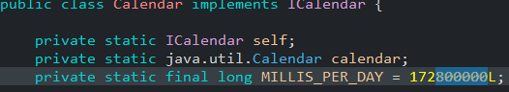
11. 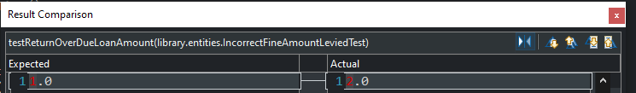
12. After:
13. 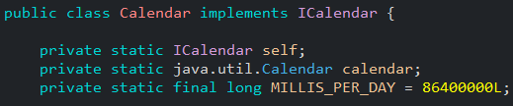
14. 
    1. Hypothesis confirmed – The bug was caused by the wrong MILLIS_PER_DAY value and correcting it fixed the bug.